SELECT transaksi.id AS id_transaksi, nama_obat, produsen, kandungan, efek_samping, jenis_obat, transaksi.jumlah as jumlah_transaksi FROM transaksi JOIN obat ON obat.id = transaksi.id_obat JOIN detail_obat ON obat.id = detail_obat.obat_id;

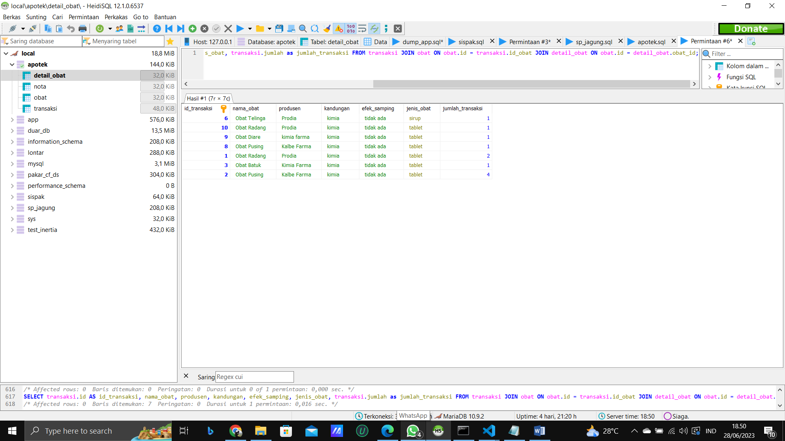

SELECT transaksi.id AS id_transaksi, nama_obat, produsen, kandungan, efek_samping, jenis_obat, transaksi.jumlah as jumlah_transaksi FROM transaksi JOIN obat ON obat.id = transaksi.id_obat JOIN detail_obat ON obat.id = detail_obat.obat_id WHERE transaksi.jumlah > 1;

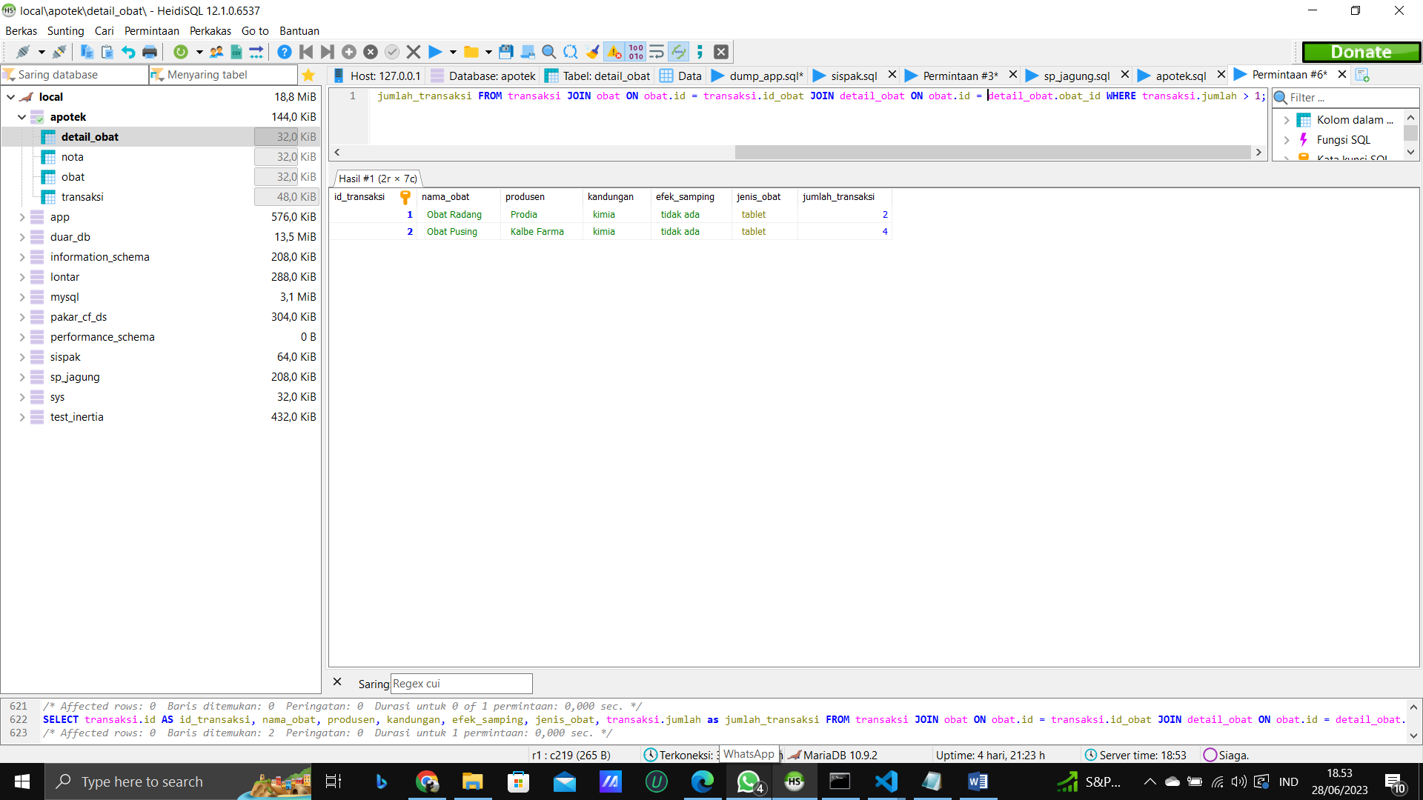

SELECT nota.kode_nota, COUNT(transaksi.id) AS total_transaksi, SUM(transaksi.jumlah) AS jumlah_obat FROM nota JOIN transaksi ON nota.kode_nota = transaksi.kode_nota JOIN obat ON obat.id = transaksi.id_obat WHERE obat.stok_obat > 20 GROUP BY nota.kode_nota;

